**CHAPTER 1**

**INTRODUCTION**

* 1. **DATABASE MANAGEMENT SYSTEM**

A DBMS makes it possible for end users to create, read, update and delete [data](http://searchdatamanagement.techtarget.com/definition/data) in a database. The DBMS essentially serves as an interface between the [database](http://searchsqlserver.techtarget.com/definition/database) and end users or [application programs](http://searchsoftwarequality.techtarget.com/definition/application-program), ensuring that data is consistently organized and remains easily accessible.

The DBMS manages three important things: the data, the database [engine](http://whatis.techtarget.com/definition/engine) that allows data to be accessed, locked and modified -- and the database [schema](http://searchsqlserver.techtarget.com/definition/schema), which defines the database’s logical structure. These three foundational elements help provide [concurrency](http://searchoracle.techtarget.com/definition/concurrent-processing), security, [data integrity](http://searchdatacenter.techtarget.com/definition/integrity) and uniform administration procedures. Typical database administration tasks supported by the DBMS include [change management](http://searchcio.techtarget.com/definition/change-management), performance monitoring/tuning and [backup](http://searchstorage.techtarget.com/definition/backup) and [recovery](http://searchstorage.techtarget.com/definition/recovery). Many database management systems are also responsible for automated [rollbacks](http://searchsqlserver.techtarget.com/definition/rollback), restarts and recovery as well as the [logging](http://whatis.techtarget.com/definition/log-log-file) and [auditing](http://searchcio.techtarget.com/definition/audit-trail) of activity.

The DBMS is perhaps most useful for providing a centralized view of data that can be accessed by multiple users, from multiple locations, in a controlled manner. A DBMS can limit what data the end user sees, as well as how that end user can view the data, providing many views of a single database schema. End users and software programs are free from having to understand where the data is physically located or on what type of storage media it resides because the DBMS handles all requests.

The DBMS can offer both logical and physical data independence. That means it can protect users and applications from needing to know where data is stored or having to be concerned about changes to the physical structure of data ([storage](http://searchstorage.techtarget.com/definition/storage) and hardware). As long as programs use the application programming interface ([API](http://searchexchange.techtarget.com/definition/application-program-interface)) for the database that is provided by the DBMS, developers won't have to modify programs just because changes have been made to the database.

With relational DBMSs ([RDBMSs](http://searchsqlserver.techtarget.com/definition/relational-database-management-system)), this API is [SQL](http://searchsqlserver.techtarget.com/definition/SQL), a standard programming language for defining, protecting and accessing data in a RDBMS.

### 1.1.1 Popular Types Of Dbms

Popular database models and their management systems include:

Relational database management system (RDMS)  - adaptable to most use cases, but RDBMS [Tier-1](http://searchitchannel.techtarget.com/definition/tier-1-vendor) products can be quite expensive. [NoSQL DBMS](http://searchdatamanagement.techtarget.com/definition/NoSQL-DBMS-Not-only-SQL-database-management-system) - well-suited for loosely defined data structures that may evolve over time. In-memory database management system (IMDBMS) - provides faster response times and better performance.Columnar database management system (CDBMS) - well-suited for [data warehouses](http://searchsqlserver.techtarget.com/definition/data-warehouse) that have a large number of similar data items.Cloud-based data management system - the [cloud service](http://searchcloudprovider.techtarget.com/definition/cloud-services) provider is responsible for providing and maintaining the DBMS.

### 1.1.2 Advantages Of A Dbms

Using a DBMS to store and manage data comes with advantages, but also overhead. One of the biggest advantages of using a DBMS is that it lets end users and application programmers access and use the same data while managing data integrity. Data is better protected and maintained when it can be shared using a DBMS instead of creating new iterations of the same data stored in new files for every new application. The DBMS provides a central store of data that can be accessed by multiple users in a controlled manner.

Central storage and management of data within the DBMS provides:

* Data abstraction and independence
* Data security
* A locking mechanism for concurrent access
* An efficient handler to balance the needs of multiple applications using the same data
* The ability to swiftly recover from crashes and errors, including restart ability and recoverability
* Robust data integrity capabilities
* Logging and auditing of activity
* Simple access using a standard application programming interface (API)
* Uniform administration procedures for data

Another advantage of a DBMS is that it can be used to impose a logical, structured organization on the data. A DBMS delivers economy of scale for processing large amounts of data because it is optimized for such operations.

A DBMS can also provide many views of a single database schema. A view defines what data the user sees and how that user sees the data. The DBMS provides a level of abstraction between the conceptual schema that defines the logical structure of the database and the physical schema that describes the files, indexes and other physical mechanisms used by the database. When a DBMS is used, systems can be modified much more easily when business requirements change. New categories of data can be added to the database without disrupting the existing system and applications can be insulated from how data is structured and stored.Of course, a DBMS must perform additional work to provide these advantages, thereby bringing with it the overhead. A DBMS will use more memory and [CPU](http://whatis.techtarget.com/definition/CPU-central-processing-unit) than a simple file storage system. And, of course, different types of DBMSes will require different types and levels of system resources.

**CHAPTER 2**

**REVIEW OF LITERATURE**

* 1. **OVERVIEW**

Wireless technology has been the enabling domain in reshaping conventional healthcare systems in conjunction with information technology (IT). Emerging technologies such as m-health, ubiquitous health monitoring as well as telemedicine have recently become widespread and attracted the attention of many researchers. The Continuous and realtime monitoring systems, as the key elements of modern caregiving systems, can effectively revolutionize the conventional healthcare systems. Wireless body sensor networks (WBSNs) have received a considerable attention as the viable alternative in achieving continuous health monitoring systems. Currently, WBSNs support a wide range of applications including fall prevention, wireless electrocardiography (ECG) (i.e., wireless ECG), and also remote respiration and temperature monitoring. As it can be deduced, different types of vital sign sensors (e.g, blood pressure, glucose, ECG and temperature) which are wirelessly networked together can incorporate in WBSNs for specific health monitoring purposes. However, currently in hospitals, patients’ vital signs are recorded and supervised several times during the course of a day by clinical staff. Human errors, lack of adequate skills, tiredness and inefficient staff in additional to shortcoming of sufficient accuracy due to wrong measurement and personal interpretation of the results can deteriorate patients’ life, especially when the number of hospitalized patients exceeds.

**2.2 DETAILS ABOUT VARIOUS APPROACHES / METHODOLOGIES**

**2.2.1 The Developed Temperature Monitoring System**

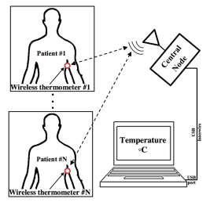

Fig 2.1- SCHEMATIC OF THE THERMOMETER’S FUNDAMENTAL PARTS

The schematic of the developed monitoring system which incorporates a number of essential components namely, the wireless thermometers and the communication infrastructure. The latter also includes a central node for transmitting and receiving the signals at the radio frequency of 2.4 GHz and a low-frequency interconnects. Additionally, a PC is used to coordinate the measurements performed by the thermometers. In sections II-A and B, the design and implementation of the thermometers and communication infrastructure will be described. A. Wireless Thermometer The schematic and a photograph of the developed wireless thermometer are represented in Fig. 2. This system operates at 2.4 GHz, one of the popular frequencies in the ISM (Industrial, Scientific and medical) band. Similar to a typical sensor node, the wireless thermometer consists of three main parts namely, a transceiver (nRF24, Nordic Semiconductor), a microcontroller (Atmega88, Atmel) and a digital temperature sensor (SHT11, Sensation AG) with the accuracy and resolution of 0.4 and 0.01C respectively. As it can be seen in Fig. 2, the transceiver uses a planar inverted-F antenna (PIFA) for transmitting and receiving the signals at the target frequency of 2.4 GHz, where the output power is approximately set at 0 dBm.

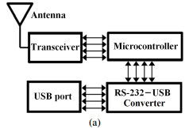

Fig 2.2- Block diagram

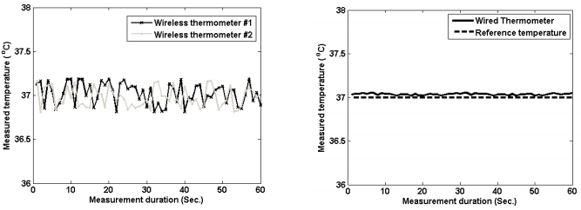

Fig 2.3- COMMUNICATION INFRASTRUCTURE

In order to visualize the measured temperature values for making necessary alerts, the thermometers are required to communicate with a PC or PDA (Personal Digital Assistant) through a central node as it is schematically represented in Fig. 1. The central node composes of a transceiver and a RS- 232 to USB port converter as the transceiver sends out the data in sets of successive sequences. Figure 3 illustrates the schematic and a photograph of the central node utilized in the monitoring system. In general, the monitoring system can utilize a number (N 2) of wireless thermometers, as shown in Fig. 1, that their unsupervised communication with the central node can result in data collision and consequently loss of information. In order to overcome the unsupervised communication, a mechanism organizing a safe access of the thermometers to the central node via the shared wireless medium is essential to be used. Also, the mechanism is required to control the duration at which an individual thermometer is allowed to transmit. Such mechanism is known as the MAC (Medium Access Control) protocols which are generally categorized in two different classes namely, the contention-based and schedule based. In the former protocols, the thermometers need to compete for the earliest transmission chance. However, it is not a reasonable alternative for the health monitoring system due to excessive delay, possible loss of critical information and also power consumption when the number of thermometers increases. Schedule-based protocols as opposed to their contention-based counterparts, can successfully be utilized in WBSNs . For instance, the TDMA (Time Division Multiple Access) schedule-based protocols dedicate a guaranteed time slot to the measuring thermometer. Also, the TDMA protocols enables the system to prevent unsupervised or simultaneous communication by thermometers, causing collision . However, the basic TDMA protocols cannot recognize the identification of the node accessing the medium, despite it is a mandatory requirement in the developed monitoring system. Therefore, the design and implementation of a new MAC protocol equipped with an identification mechanism, contrary to most of the MAC protocols used in WBSNs, is found to be essential.

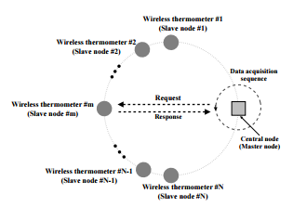

**2.2.2 A Foot Temperature Measuring System For Diabetic Patients**

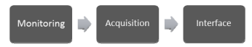

Fig 2.4- EXPERIMENTAL DESIGN

Diabetic foot ulcers (DFUs) are a major precursor to lower-limb amputations and a prominent cause of morbidity in patients with diabetes. There are several points on the foot susceptible to ulcers that are directly related to a temperature change. The aim of this study was to design and implement a foot temperature monitoring system. This system is capable of recording the temperature of four foot areas more susceptible to ulceration and then analyzed and processed the data collected. We tested our system over five diabetic and non-diabetic patients. The results indicate that there is a temperature difference between the right and the left foot on some of the diabetic patients.

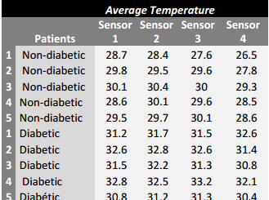

Fig 2.5 TEST RESULTS

**2.2.3 Temperature Monitoring System Incorporating An Array Of Precision Wireless Thermometers**

This paper addresses the design and implementation of a real-time temperature monitoring system with applications in telemedicine. The system consists of a number of precision wireless thermometers which are conceived and realized to measure the patients’ body temperature in hospitals and the intensive care units (ICUs). Each wireless thermometer incorporates an accurate semiconductor temperature sensor, a transceiver operating at 2.4 GHz and a microcontroller that controls the thermometer functionalities. An array of two thermometers are implemented and successfully evaluated in different scenarios, including free-space and in vivo tests. Also, an in-house developed computer software is used in order to visualize the measurements in addition to detecting rapid increase and alerting high body temperature. The agreement between the experimental data and reference temperature values is significant.

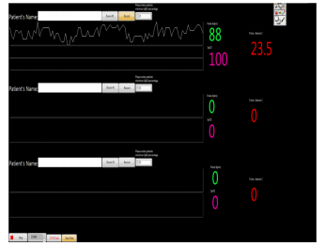

Fig 2.6-TEST RESULTS

**CHAPTER 3**

**SYSTEM ANALYSIS**

* 1. **EXISTING SYSTEM**

The current state and projected future directions for integration of remote health monitoring technologies into the clinical practice of medicine. Wearable sensors, particularly those equipped with IoT intelligence, offer attractive options for enabling observation and recording of data in home and work environments, over much longer durations than are currently done at office and laboratory visits. This treasure trove of data, when analyzed and presented to physicians in easy-to-assimilate visualizations has the potential for radically improving healthcare and reducing costs. We highlighted several of the challenges in sensing, analytics, and visualization that need to be addressed before systems can be designed for seamless integration into clinical practice.

**3.2 PROPOSED SYSTEM**

A database is a collection of related data, which are organized to extract useful information . The effectiveness of databases derives from the fact from one single, comprehensive database much of the information relevant to a variety of organizational purposes may be obtained. In health care the same database may be used by medical personnel for patient care recording, for surveillance of patient status, and for treatment advice; it may be used by researchers in assessing the effectiveness of drugs and clinical procedures; and it can be used by administrative personnel in cost accounting and by management for the planning of service facilities.

The fact that data are shared promotes consistency of information for decision-making and reduces duplicate data collection. A major benefit of databases in health care is due to the application of the information to the management of services and the allocation of resources needed for those services, but communication through the shared information among health care providers, and the validation of medical care hypotheses from observations on patients are also significant.

The contents and the description of a database has to be carefully managed in order to provide for this wide range of services.The formalization, and the large data quantity implied in effective database operations make computerization of the database function essential; in fact, much of the incentive for early is due to the demands made by information processing needs.

* 1. **PROJECT MOTIVATION**

The current method of monitoring patients in hospitals keeps patients tied to their beds and can be uncomfortable for patients to wear. The number of nurses in the workforce is also expected to decline by 2020, causing strain in an environment where excess pressure can lead to unfortunate accidents happening to patients. The goal of this project was to produce a wireless patient monitoring system that could allow patients to be mobile in their environment. The developed system includes a pulse oximeter to measure blood oxygen concentration and the patient’s pulse, as well as a temperature sensor to keep track of the patient’s temperature. The proof of concept was successful, and allowed for multiple patients at the same time on the same network with the ability to add many more patients. This project was primarily undertaken by two undergraduate students during an NSF sponsored 10-week Research Experiences for Undergraduates (REU) summer program.

* 1. **PROJECT DEFINITION**

The aim of the project describes the design and implementation of a real-time monitoring system for obtaining the human body temperature in a continuous manner. The system comprises of a number of precision wireless thermometers and a communication infrastructure which is used for handling the measurement results. In comparison to previously reported temperature monitoring systems and, the proposed system consists in a built-in identification mechanism in order to specify the measurement performed by a given thermometer. This identification mechanism can enable the monitoring system to potentially utilize a large number of thermometers. However, the maximum number of the thermometers are limited by the rate of temperature increase and required accuracy. Additionally, the system is able to detect rapid increase and high body temperature of the patient who wearing the wireless thermometer.

**CHAPTER 4**

**SYSTEM SPECIFICATION**

**4.1 HARDWARE REQUIREMENTS**

Processor : Intel Pentium

Speed : 2.93 GHz RAM

Capacity : 2GB

Hard disk : 500 GB

Motherboard: Intel

**4.2 SOFTWARE REQUIREMENTS**

Operating System : WINDOWS 7.0 & Above

Software : MP LAB IDE,PROTEUS SIMULATION TOOL,HI

TECH C COMPILER

**CHAPTER 5**

**SOFTWARE DESCRIPTION**

LabVIEW is an acronym for **Lab**oratory **V**irtual **I**nstrument **E**ngineering **W**orkbench. It is a computer software development application created by National Instruments™ (Austin, Texas) that aims to aid scientists and researchers in gathering and understanding data using computer programs. LabVIEW is a *G* graphical programming software that utilizes graphical objects to symbolize lines of code instead of the average programmers’ text-based languages. In the source code of this graphical program, data execution depends on the flow of data. What may take days in C++ or Java written code is cut down to hours in G programming. Add to this, LabVIEW has built a general purpose library of functions and subroutines for most programming tasks. The time saved allows the user to fully focus and understand how data is flowing. Even though some type of programming experience is useful, a novice in text-based programming language(s) can grasp the mechanics of LabVIEW because it is a graphical programming language utilizing iconic symbols to illustrate program action. is an example of the similarity and difference between written code and LabVIEW source code.

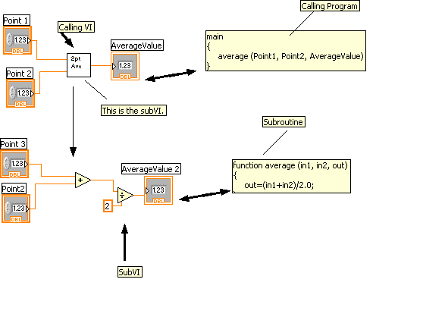

Figure5.1 TEXT-BASED PROGRAMMING COMPARED WITH LABVIEWS SOURCE CODE.

### 5.1 OPERATING LABVIEW

The building blocks of the LabVIEW program are called Virtual Instruments. The name comes from the fact that the program emulates the appearance and tasks of physical instruments while still operating in the same capability as a text-based program. There are three key components to any VI: the front panel, the block diagram, and the icon and connector pane. The below figure shows the front panel and block diagram of a typical VI.



Figure 5.2 FRONT PANEL AND BLOCK DIAGRAM OF VI.

#### **5.2 FRONT PANEL**

The front panel is the VI’s interactive interface built with controls (inputs) and indicators (outputs) that replicate conventional instruments, like thermostats or knobs, as may be found in the real world.

The controls that are built on the front panel are wide-ranging as seen in the ‘Control’ tool palette in Figure 5.2.

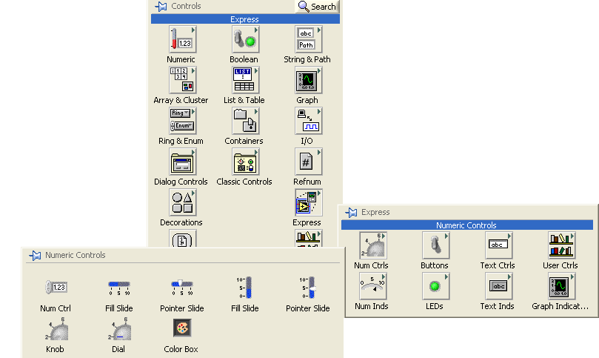

Figure 5.2: THE 'CONTROL' PALETTE OF THE FRONT PANEL.

**CHAPTER 6**

**PROJECT DESCRIPTION**

**6.1 PROPOSED SYSTEM**

The goal of the project is to produce a wireless patient monitoring system that could allow patients to be mobile in their environment. The developed system includes a pulse oximeter to measure blood oxygen concentration and the patient’s pulse, as well as a temperature sensor to keep track of the patient’s temperature. The proof of concept was successful, and allowed for multiple patients at the same time on the same network with the ability to add many more patients.

**6.2 MODULES:**

* Microcontroller with UART Output module
* Data Acquisition
* Calibration
* Graph generation

**6.2.1 Microcontroller With UART Output Module**

UART stands for Universal Asynchronous Receiver / Transmitter. It is a very popular serial communication interface which provides Full Duplex communication between two devices. UART uses two data lines for sending (TX) and receiving (RX) data. Ground/Reference of both devices should be made common. As the name indicates it is an asynchronous communication interface, which means that it doesn’t need to send CLOCK along with data as in synchronous communications. UART is the communication interface used by our old computer’s RS-232 port.

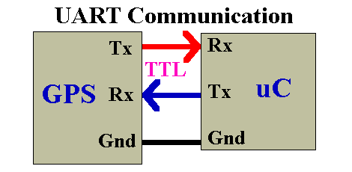

Figure 6.1 UART COMMUNICATION

**6.2.2 Data Acquisition**

Data acquisition (DAQ) is the process of measuring an electrical or physical phenomenon such as voltage, current, temperature, pressure, or sound with a computer. A DAQ system consists of sensors, DAQ measurement hardware, and a computer with programmable software. Compared to traditional measurement systems, PC-based DAQ systems exploit the processing power, productivity, display, and connectivity capabilities of industry-standard computers providing a more powerful, flexible, and cost-effective measurement solution. The measurement of a physical phenomenon, such as the temperature of a room, the intensity of a light source, or the force applied to an object, begins with a sensor. A sensor, also called a transducer, converts a physical phenomenon into a measurable electrical signal. Depending on the type of sensor, its electrical output can be a voltage, current, resistance, or another electrical attribute that varies over time. Some sensors may require additional components and circuitry to properly produce a signal that can accurately and safely be read by a DAQ device.

**6.2.3 Calibration**

The present temperature and humidity status can be viewed by clicking the “Acquire” Button on the main screen. A dialog box pops up immediately after the button is clicked which asks the user to enter a file name and choose a location for the creation of a data log file with a DAT extension. The user may see the temperature and humidity values with names of their specific areas configured in the form of plot names. These values are available both numerically and graphically along with time stamp. “Start logging” button has to be clicked whenever the user wants to start the logging operation. Whenever these values cross the specified limits, a red alert message pops up either for temperature or humidity and it can be seen which particular area it is. Moreover, the buzzer also rings when the limits are crossed to alert the user properly.

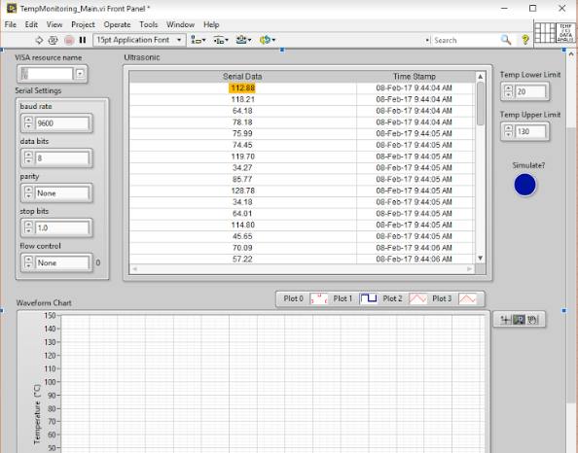

Figure 6.2 COLLECTION OF DATA

**6.2.4 Graph Generation**

The data log created previously is available for subsequent analysis. The “Analysis” button when clicked from the main screen prompts the user to enter a file name that he would like to analyze. This function shows a plot of the values recorded previously with the start time/date and stop time/date. These values depicted in the graph can also be seen on Microsoft Excel by exporting them.

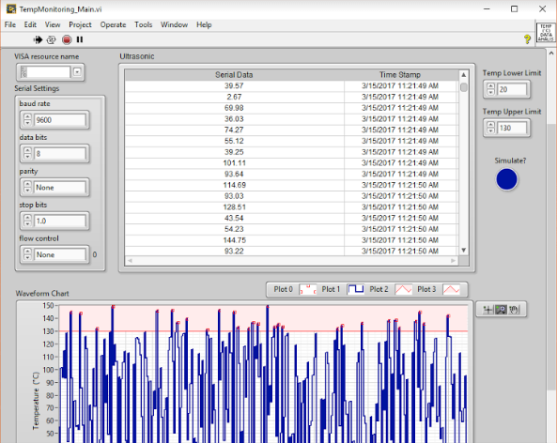

Figure 6.3 GRAPH REPRESENTATION OF THE SYSTEM

**CHAPTER 7**

**CONCLUSION AND FUTURE ENHANCEMENT**

**7.1 FUTURE ENHANCEMENT**

The system includes the temperature of the patient that are being monitored at a time interval and graph is generated.The parameters that increases temperature can be added and other features available in the algorithm can be used for adding extra modules in it, also the software provided are enhanced based on the evolutions.

**7.2 CONCLUSION**

Thus the “**Health Monitoring Using Database Management System**” aims to predict the chances of health issues by monitoring the temperature and the pulse of the patient in the regular interval of time.

**CHAPTER 8**

**APPENDIX**

**APPENDIX 1: SCREENSHOTS**

**LABVIEW FRONT PANEL**

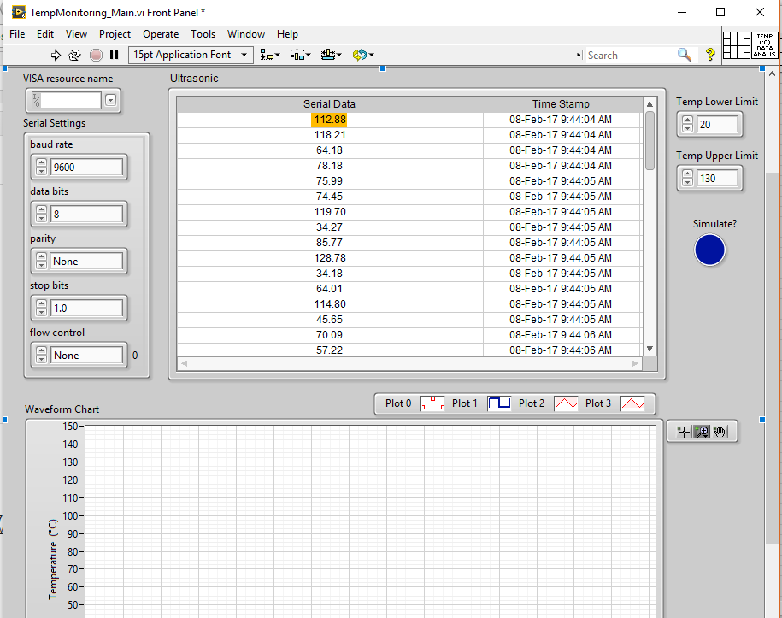

FRONT PANEL of Labview having LOG file and tempeture waveform with the VISA configuration of UART.

**INTERNAL BLOCK DIAGRAM**

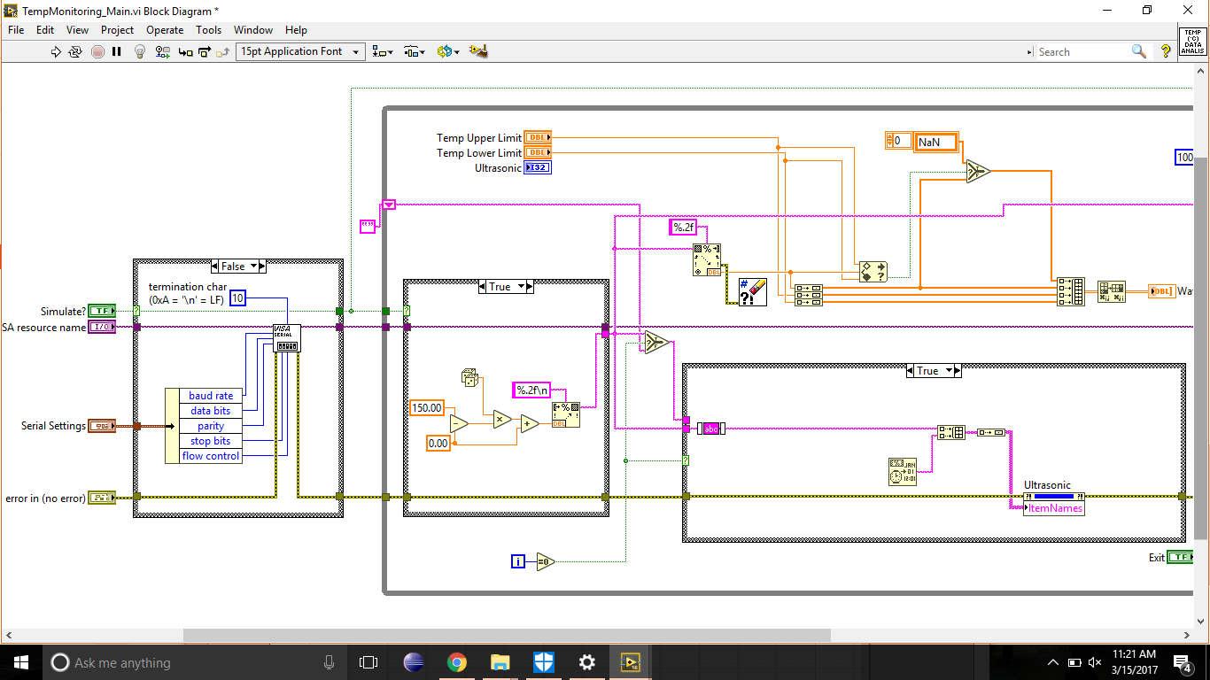

Here we get the temperature output from the KIT with calibrated data also we setting up the abnormal temperature and the normal values in this code

**GRAPH GENERATION CODING PANEL**

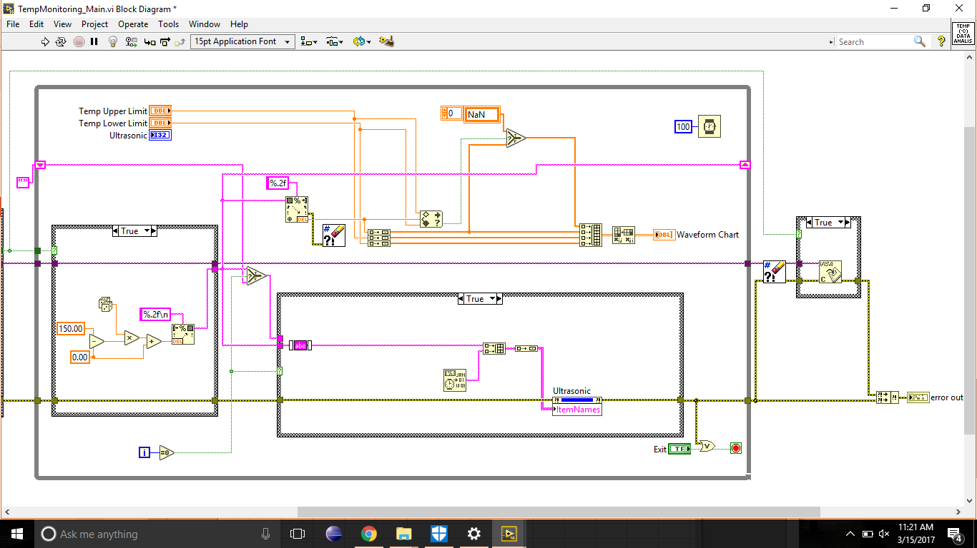

Here we calibrated data to analog values for graph generation

**GENERATED OUTPUT WITH GRAPH VALUE**

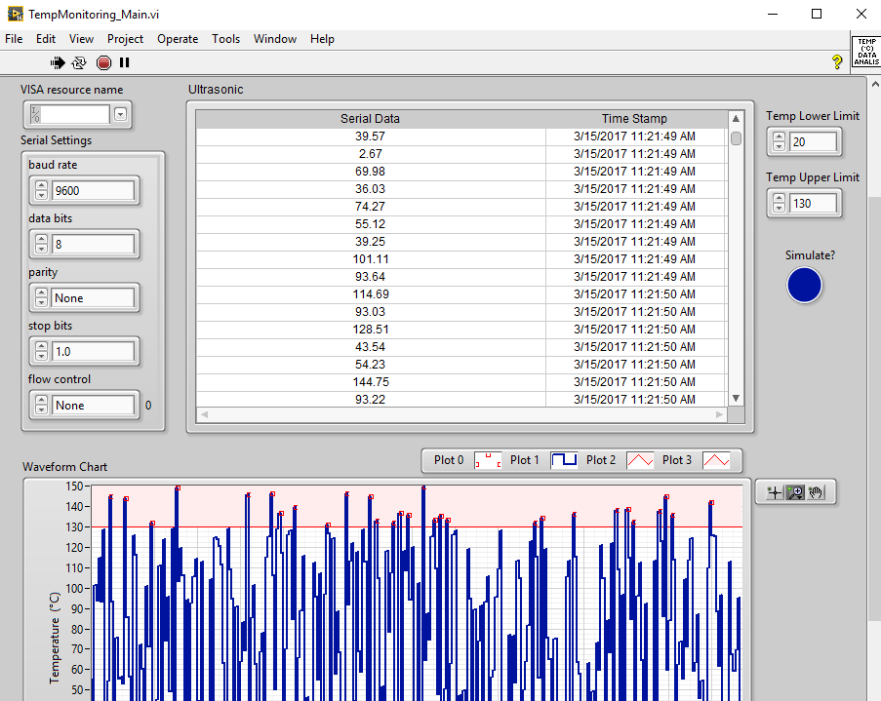

Calibrated output with graph plots as per the setting values.

**APPENDIX 2 : CODING**

KIT CODING:

#include<pic.h>

#include<htc.h>

#include"Delay.c"

#define FREQ_XTAL 20MHZ

__CONFIG(HS & WDTDIS & PWRTEN & BOREN & LVPDIS & UNPROTECT);

void enable()

{

RE2=1;

DelayMs(10);

RE2=0;

}

void lcd_cmd(unsigned int cmd)

{

PORTD=cmd;

enable();

}

void lcd_data(unsigned int lcddata)

{

RE0=1;

PORTD=lcddata;

enable();

RE0=0;

}

void string(const char *p)

{

while (*p)

{

lcd_data(*p++);

}}

main()

{

int p0=0,p1=0,x;

const unsigned char aac[]={"0123456789"};

PORTA=0x00;TRISA=0x01;

TRISD=PORTD=TRISE=PORTE=TRISC=PORTC=0x00;

ADCON1=0x06;

lcd_cmd(0x01);

lcd_cmd(0x38);

lcd_cmd(0x0C);

lcd_cmd(0x06);

while(1)

{

ADCON1=0xc4;

ADCON0=0x05;

x=ADRESH;

x=x+ADRESL;

x=x*0.488758553;

p0=x%10;

p1=x/10;

ADCON1=0x06;

RA5=1;

lcd_cmd(0x84);

string("Temp:");

lcd_data(aac[p1]);

lcd_data(aac[p0]);

lcd_data(0xdf);

lcd_data('C');

}}

**APPENDIX 3: PUBLICATION**

**CHAPTER 9**

**REFERENCES**

[1] R. .G.K and K. Baskaran, “A Survey on Futuristic Health Care System: WBANs,” Procedia Engineering, vol. 30, pp. 889–896, 2012.

[2] F. Viani, M. Donelli, G. Oliveri, A. Massa, and D. Trinchero, “A WSNbased system for real-time electromagnetic monitoring,” in Antennas and Propagation (APSURSI), 2011 IEEE International Symposium on, 2011, pp. 3129–3132.

[3] K. Roback, “An overview of temperature monitoring devices for early detection of diabetic foot dosorders,” Expert review of medical devices, vol 5, pp. 711-718, 2010.

[4] Archer, A. G., Roberts, V. C., & Watkins, P. J. “Blood flow patterns in painful diabetic neuropathy”, Diabetologia, vol. 27, pp. 563–567, 1984.

[5] T. Giao, C. Pesto, L. Selavo, Y. Chen, J. Ko, J. Lim, A. Terzis, A. Watt, J. Jeng, B. Chen, K. Lorincz, and M. Welsh, "Wireless Medical Sensor Networks in Emergency Response: Implementation and Pilot Results," IEEE Conference on Technologies for Homeland Security, pp. 187-192, May 2008.

[6] Sotera Wireless, "ViSi Mobile | A Product by Sotera Wireless," Available: http://www.visimobile.com/. (Accessed August 25, 2014).